JAVASCRIPT

1.

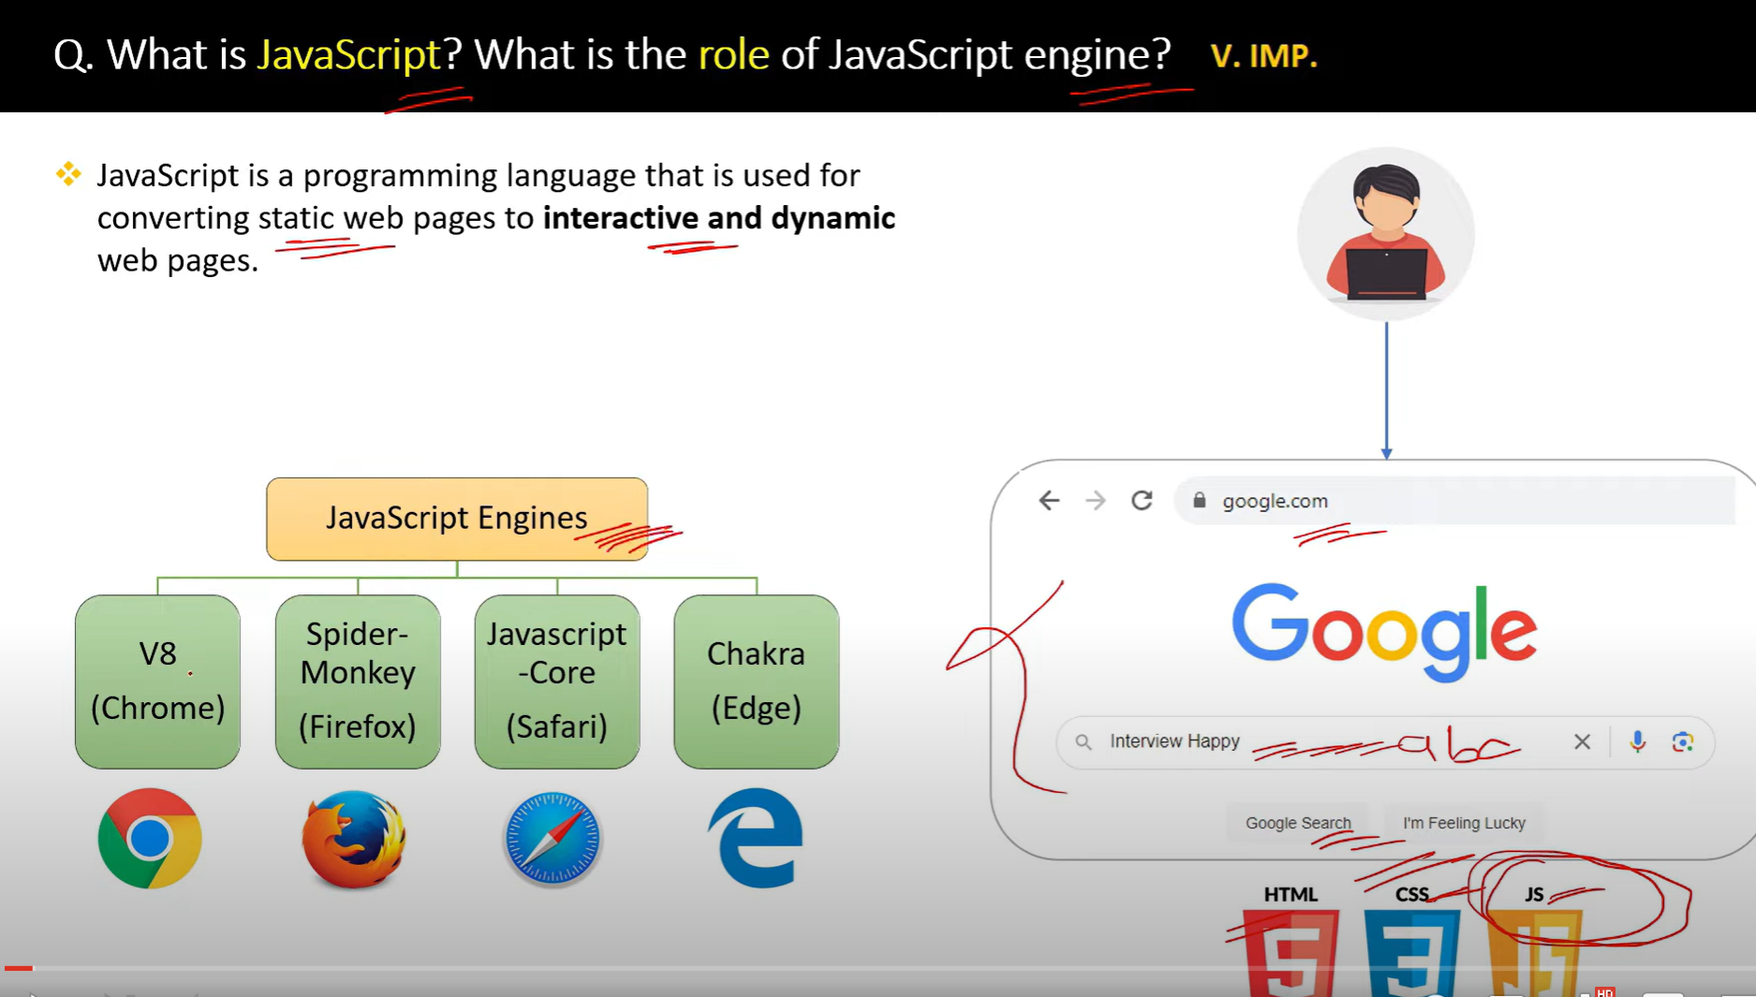

**JavaScript (JS)** is a high-level, dynamic, and interpreted programming language that is widely used to create interactive, dynamic content for websites. Originally developed to enable client-side scripting in web browsers, JavaScript has grown into a versatile language used in various environments, including web servers, mobile apps, desktop applications, and more.

**Key Characteristics of JavaScript:**

1. **Interpreted Language**:
   * JavaScript code is executed line by line by the browser's JavaScript engine, without needing to be compiled.
2. **Client-Side Scripting**:
   * JavaScript primarily runs in the browser to enhance user interaction. It allows developers to manipulate web content, handle events, validate user input, and create interactive websites.
3. **Event-Driven**:
   * JavaScript allows handling events such as user clicks, form submissions, or keyboard inputs, making websites responsive and interactive.
4. **Lightweight and Fast**:
   * JavaScript is lightweight and designed to work quickly, providing instant responses to user actions.
5. **Dynamic Typing**:
   * Variables in JavaScript are not explicitly typed. The same variable can hold different types of values at different times (e.g., numbers, strings, or objects).
6. **Object-Oriented Programming (OOP)**:
   * While JavaScript uses prototypes instead of traditional class-based inheritance, it still supports object-oriented programming principles like encapsulation, inheritance, and polymorphism.
7. **Multi-paradigm**:
   * JavaScript supports various programming paradigms, including imperative (procedural), object-oriented, and functional programming.
8. **Runs Everywhere**:
   * JavaScript can be used both on the client side (in the browser) and on the server side (with

2.

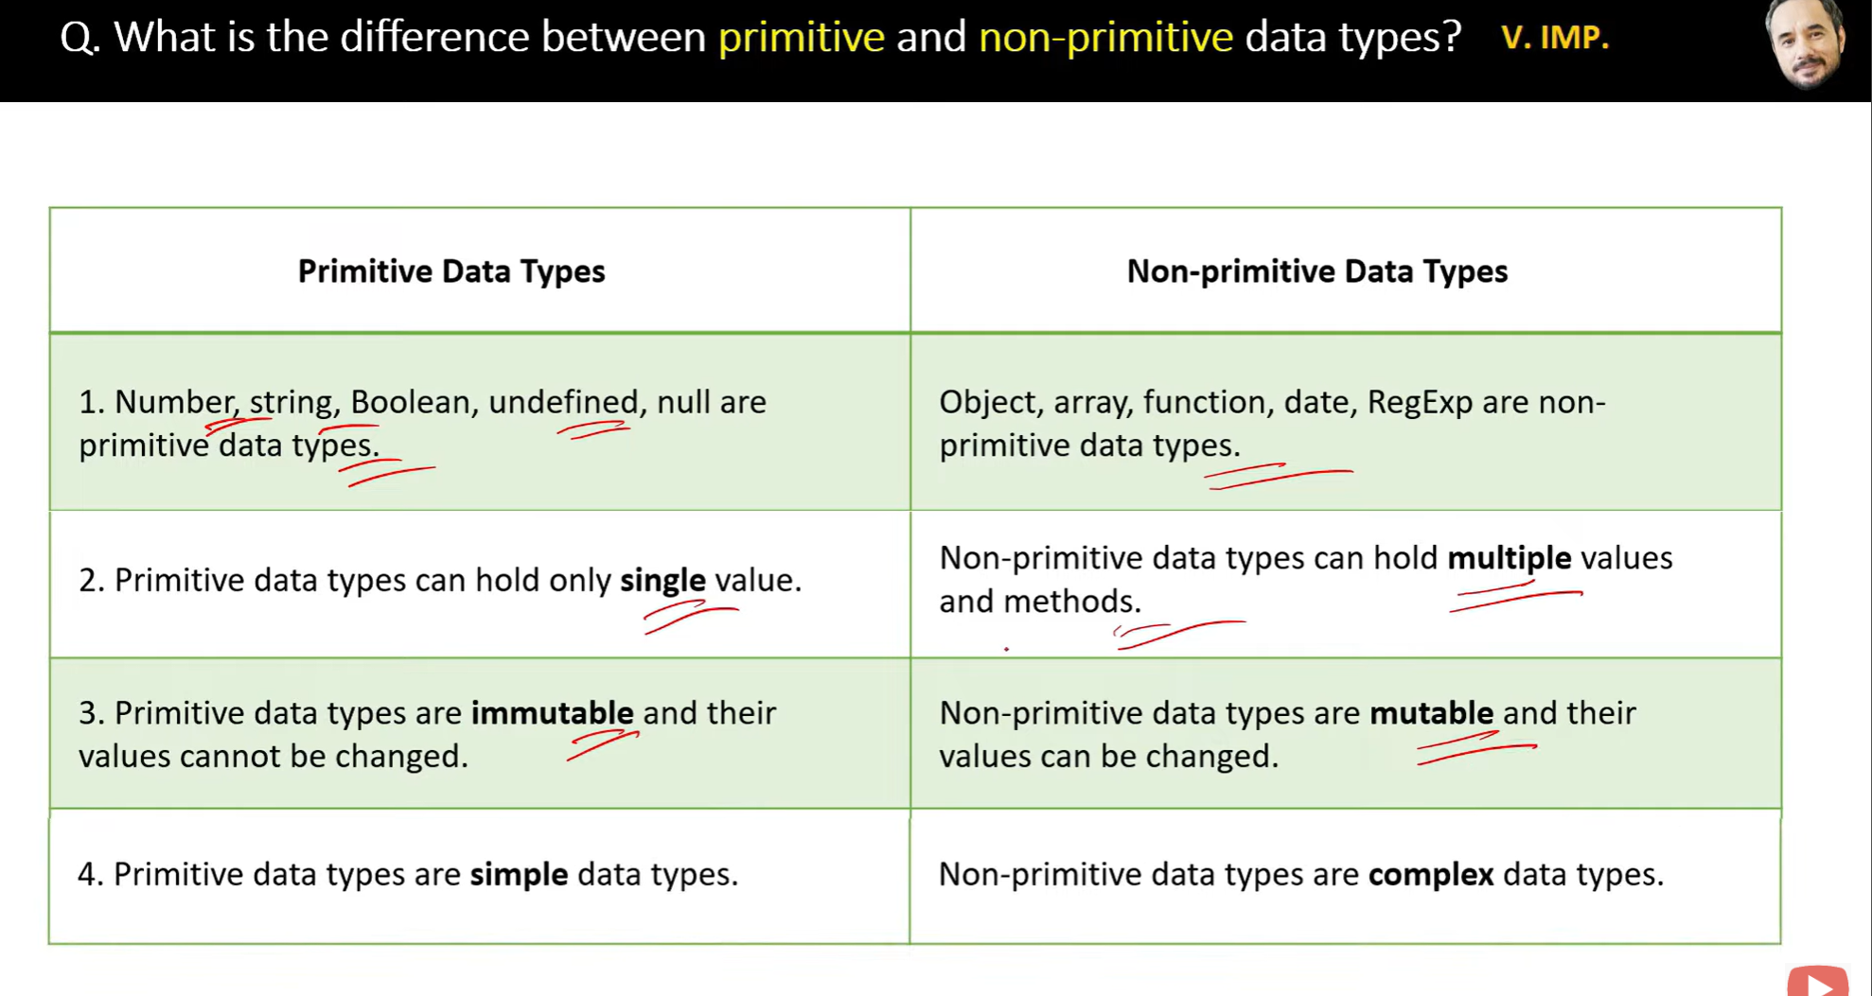

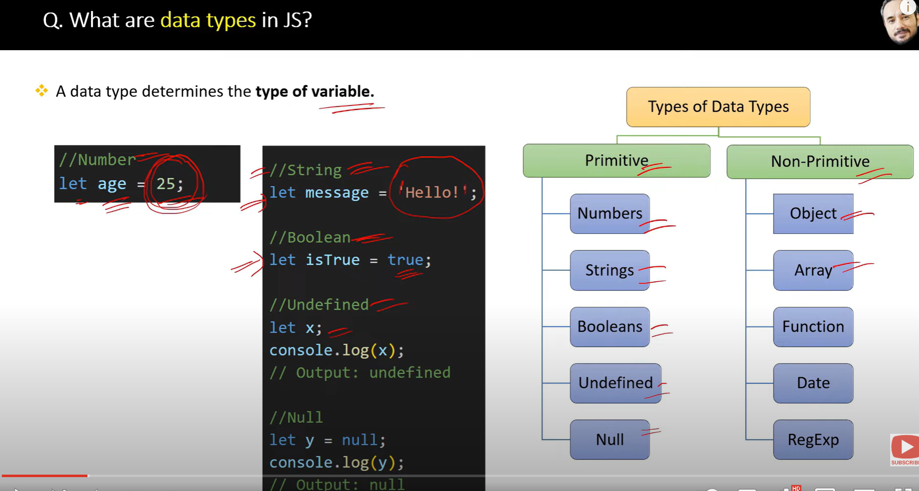

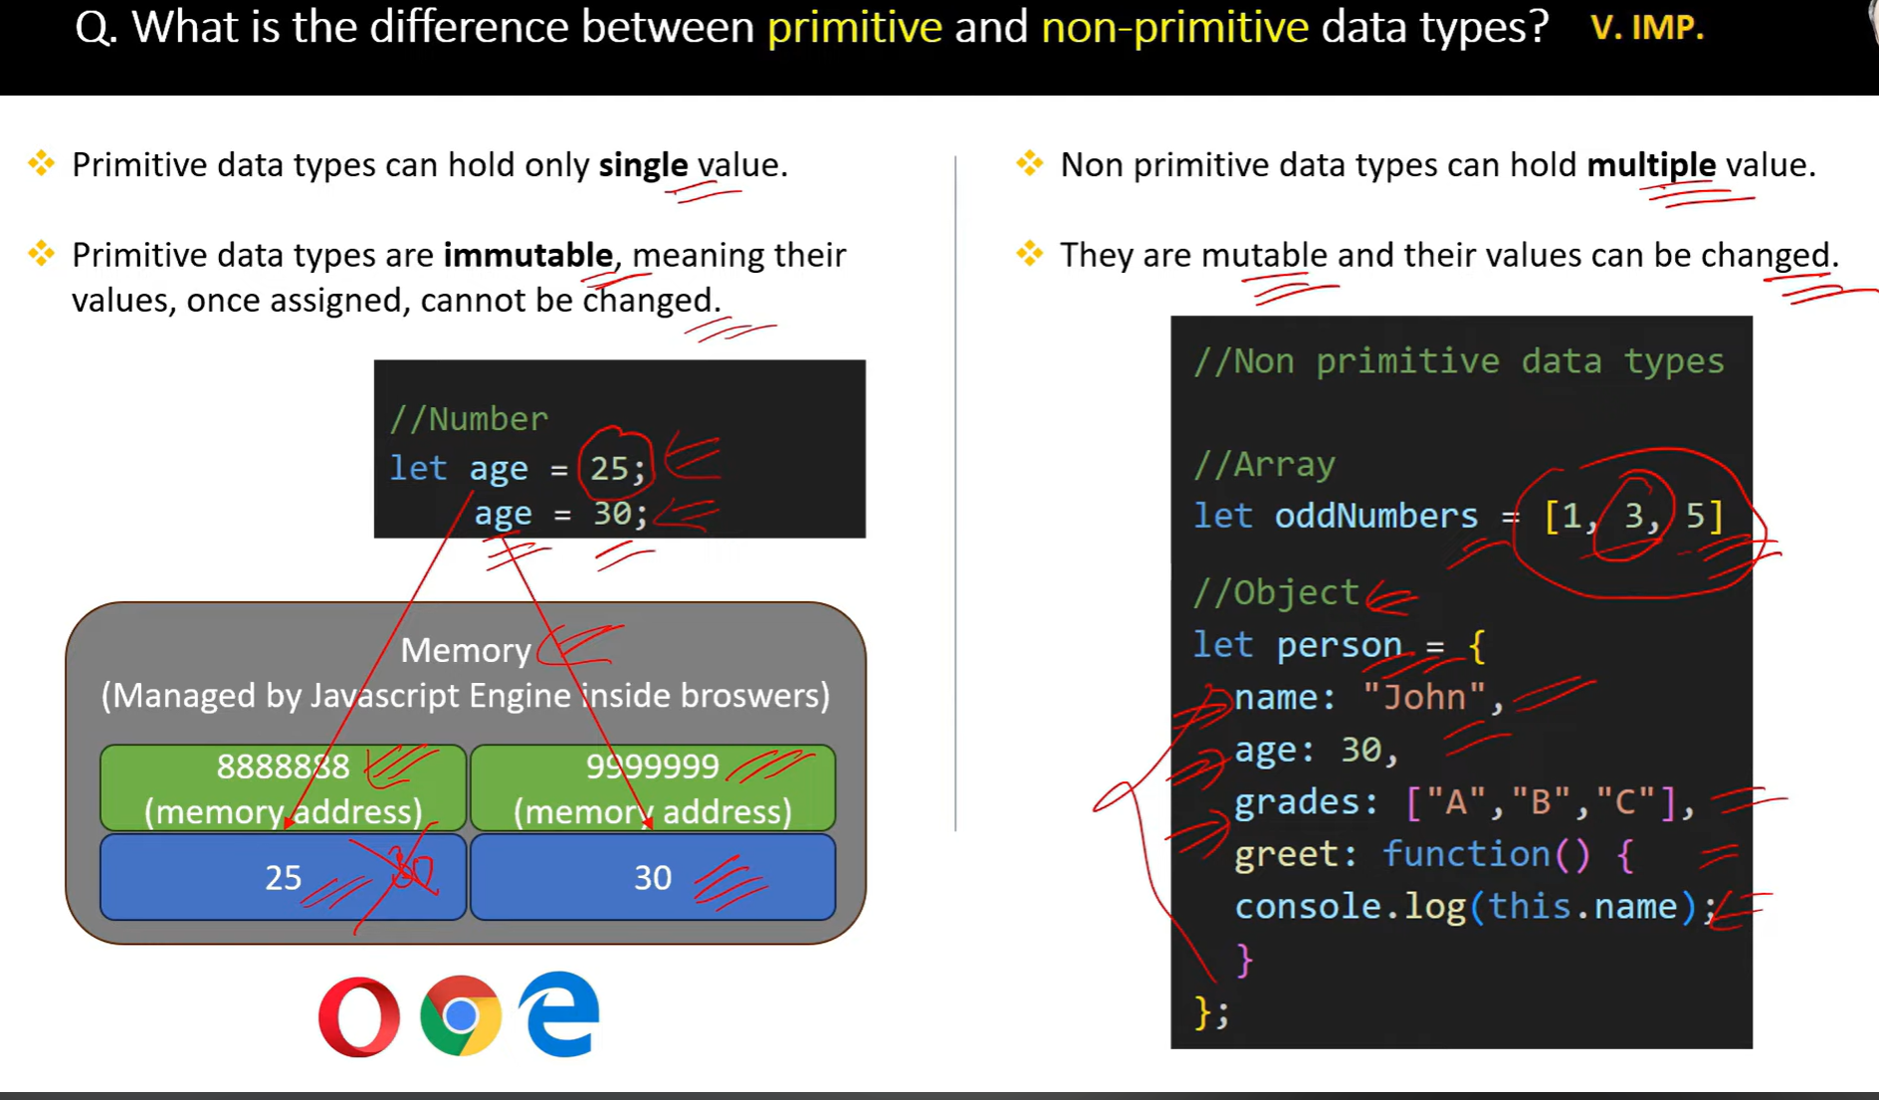

A **mutable** object or variable can be modified after it is created.

An **immutable** object or variable cannot be modified after it is created.

3.

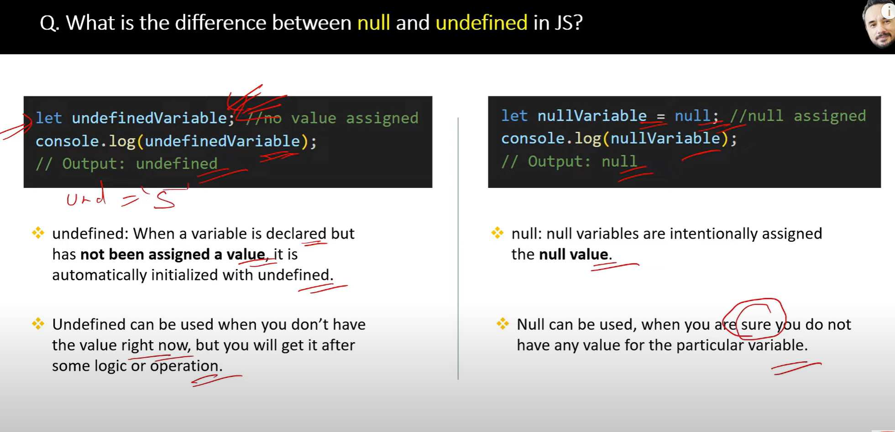

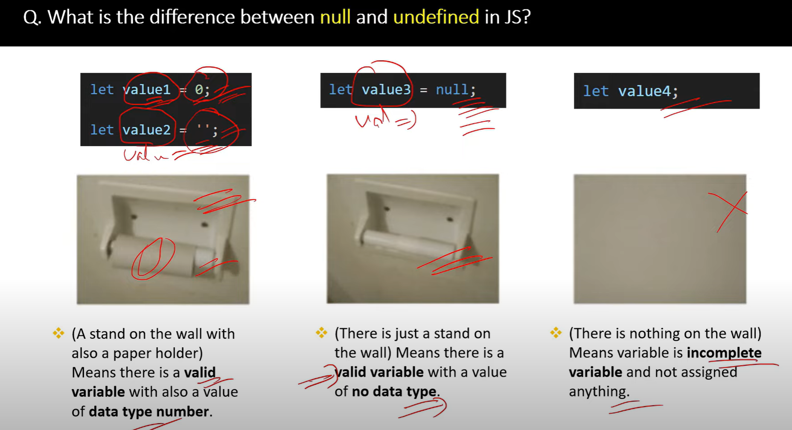

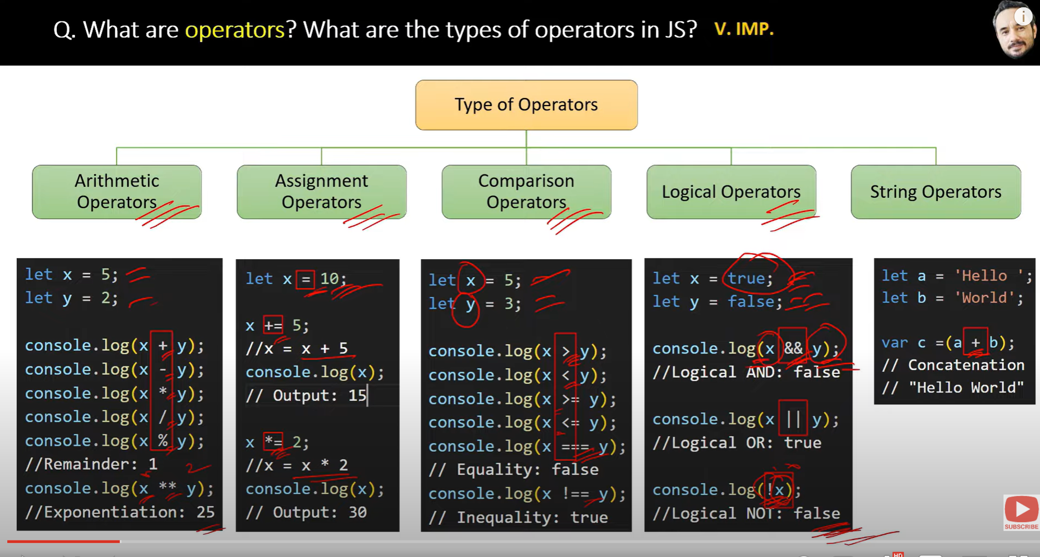

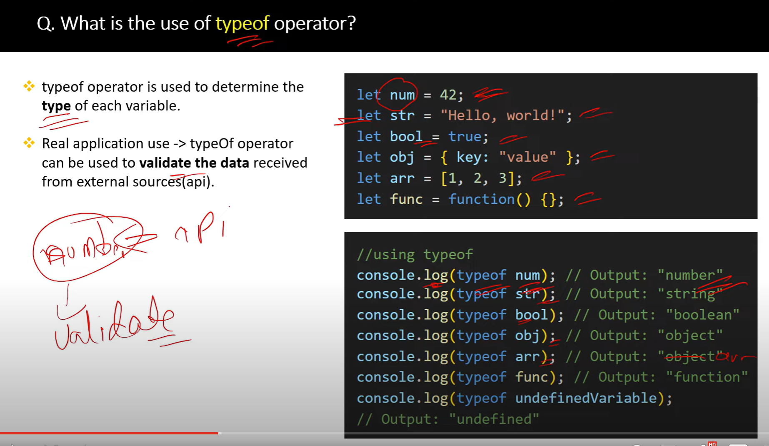

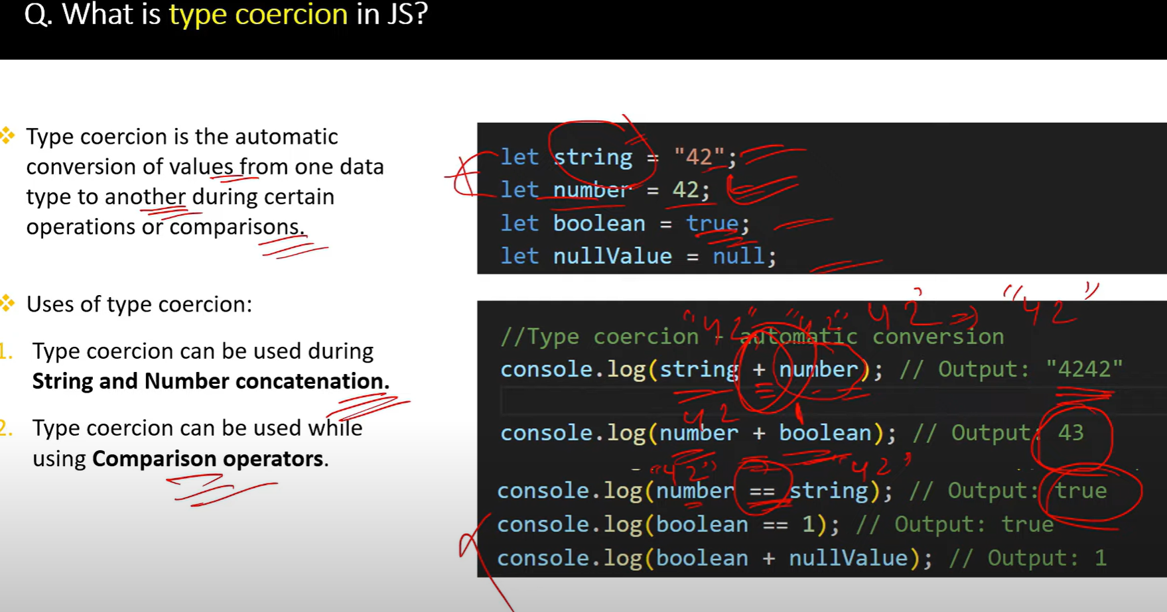

**True** is considered as **1**

**False** is considered as **0**

/*

Type Coercion Interview Questions and Examples

Q1: What is type coercion in JavaScript?

A: Type coercion is the automatic conversion of values from one data type to another when performing operations.

There are two types of coercion:

<!-- - Implicit (automatic): When JavaScript automatically converts the data type of a value to another data type. For example, when a string is concatenated with a number, the number is implicitly coerced to a string.

- Explicit (manual): When the developer explicitly converts the data type of a value to another data type. For example, using the Number() function to convert a string to a number. -->

Examples:

*/

// 1. String Coercion

console.log("1" + 2); // "12"

console.log(1 + "2"); // "12"

console.log(1 + 2 + "3"); // "33" - 1+2 is calculated first, then concatenated with "3"

// 2. Numeric Coercion

console.log("3" - 2); // 1

console.log("5" * 2); // 10

console.log("10" / 2); // 5

/*

Q2: What's the difference between == and === operators?

A: == performs type coercion before comparison, while === does not perform type coercion

*/

console.log(5 == "5");   // true - type coercion happens

console.log(5 === "5");  // false - no type coercion

/*

Q3: What are truthy and falsy values in JavaScript?

A: When non-boolean values are coerced to boolean, they become either true (truthy) or false (falsy)

*/

// Falsy values:

console.log(Boolean(false));     // false

console.log(Boolean(0));         // false

console.log(Boolean(""));        // false

console.log(Boolean(null));      // false

console.log(Boolean(undefined)); // false

console.log(Boolean(NaN));       // false

// Truthy values:

console.log(Boolean(true));      // true

console.log(Boolean(1));         // true

console.log(Boolean("hello"));   // true

console.log(Boolean([]));        // true

console.log(Boolean({}));        // true

/*

Q4: How does JavaScript coerce values in logical operations?

A: In logical operations, values are coerced to boolean

*/

console.log("hello" && 0);     // 0 (returns last falsy value or last value)

console.log("hello" || 0);     // "hello" (returns first truthy value)

console.log(!!"hello");        // true (double negation coerces to boolean)

/*

Q5: What happens when we add arrays or objects?

A: Arrays are converted to strings before addition, objects are converted to primitives

*/

console.log([] + []);         // "" (empty string)

console.log([1,2] + [3,4]);   // "1,23,4"

- This code concatenates two arrays into a string. The arrays are first converted to strings using their toString() method, resulting in "1,2" and "3,4". Then, these strings are concatenated using the + operator, resulting in "1,23,4".

console.log({} + []);         // "[object Object]"

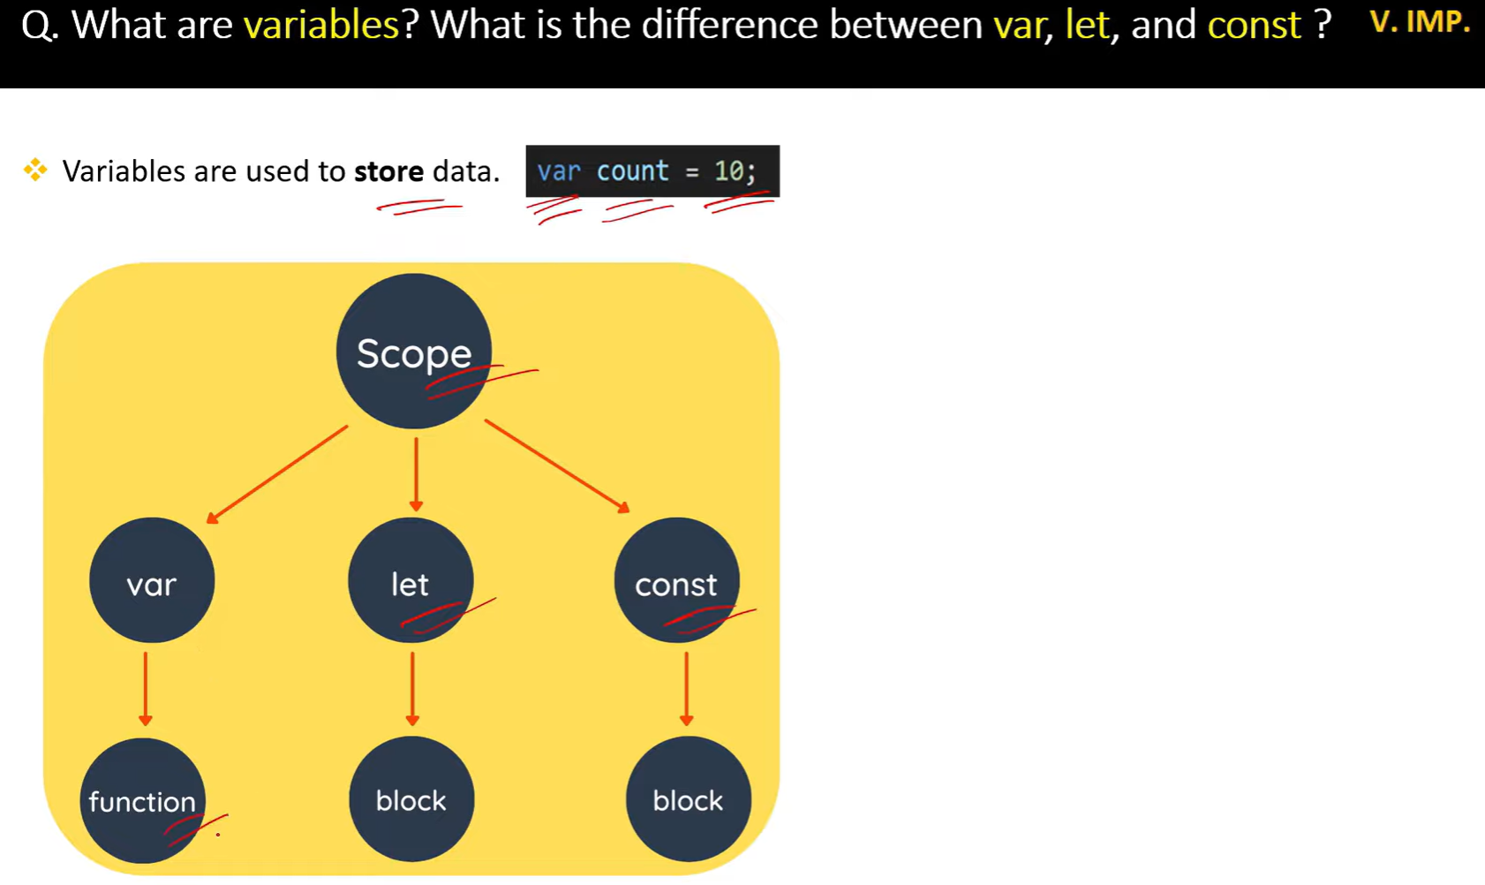

//===========================scope ========================

var  // functional scope

let and const //block scope

// global scope

Functional scope

var x = 10;

if (true) {

var x = 20;

}

console.log(x); 20

let b= 10

function Test (){

    var a= 5

    console.log(a) // 5x

    console.log(b) // 10

}

console.log(a)  //a is not defined

// block scope

let y = 10;

if (true) {

let y = 20;

}

console.log(y); // 10

{

 var a =5;

 const b =10;

    console.log(a) //5

    console.log(b) //10

}

console.log(a) //5

console.log(b) //b is not defined error

//====================variable shadowing=================

function Test(){

    let a= "Hello"

    if(true){

        let a="Hi"

        console.log(a) //Hi

    }

    console.log(a) //Hello

}

Test()

//=====================Illegal shadowing============

function test() {

    var a = "Hello";

    let b = "Bye";

    if (true) {

    let a = "Hi";

    var b = "Goodbye";

    console.log(a);   // Hi

    console.log(b);  //Identifier 'b' has already been declared

    }

    }

    test();

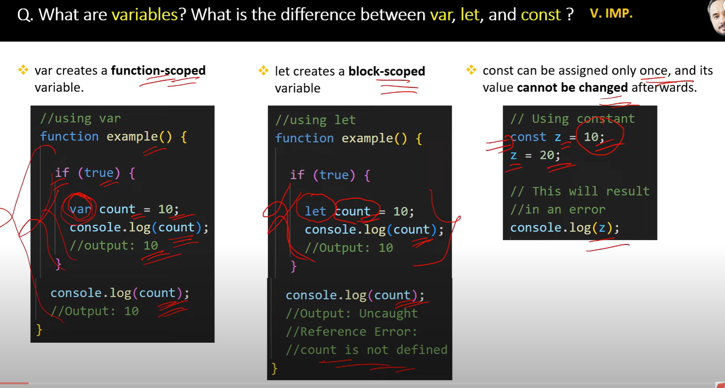

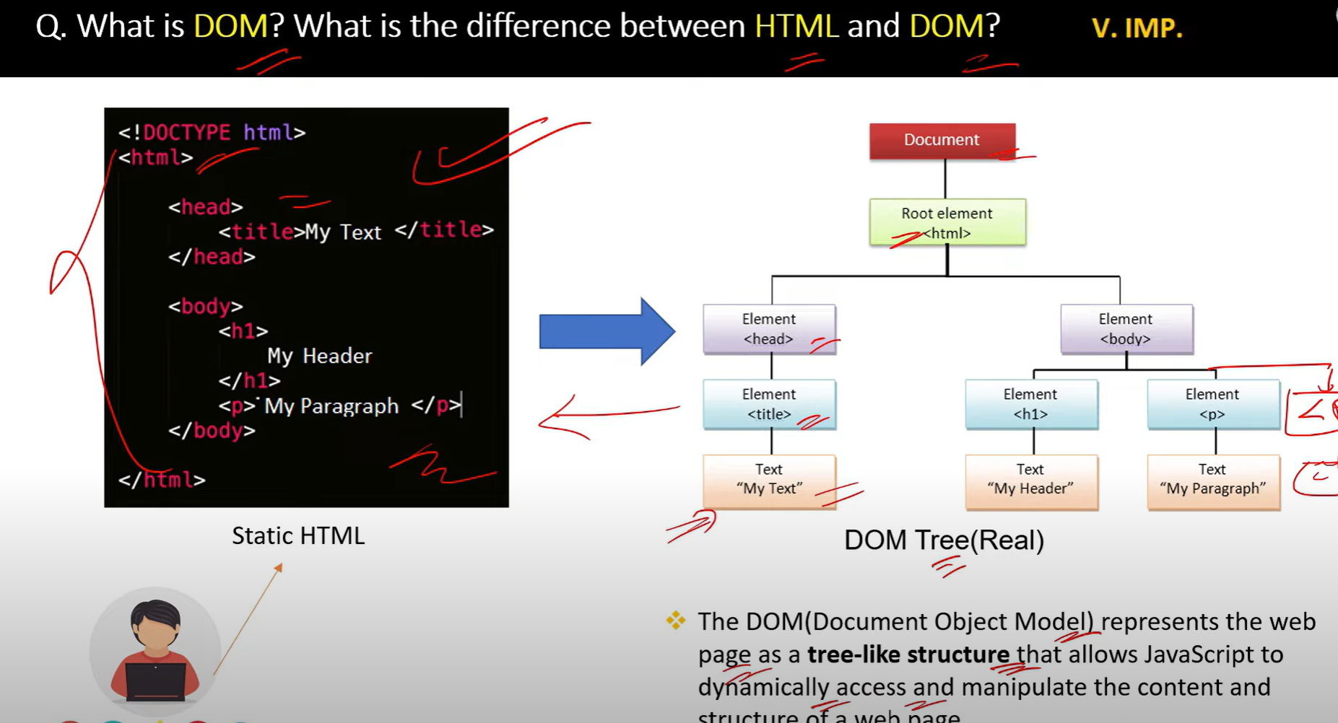

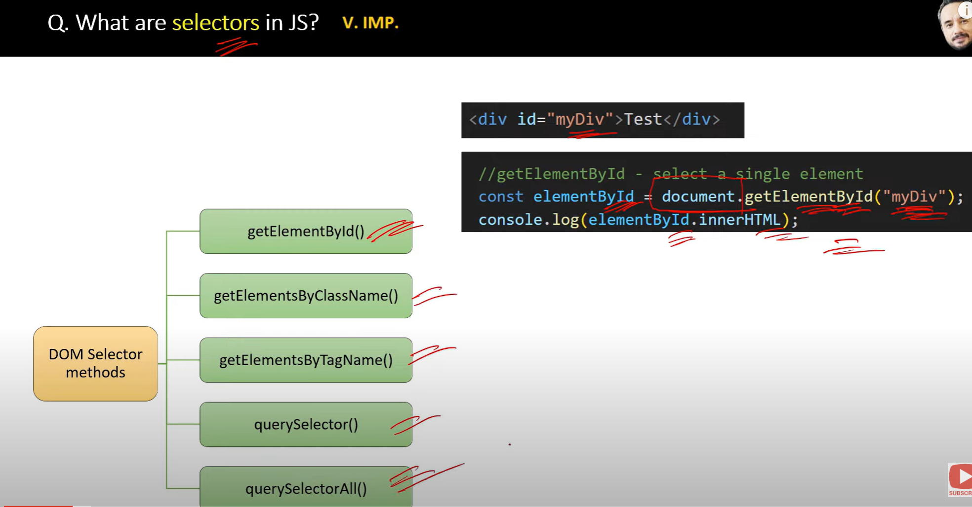

**selectors** refer to ways of selecting or accessing elements from the **Document Object Model (DOM)**, allowing developers to manipulate and interact with those elements

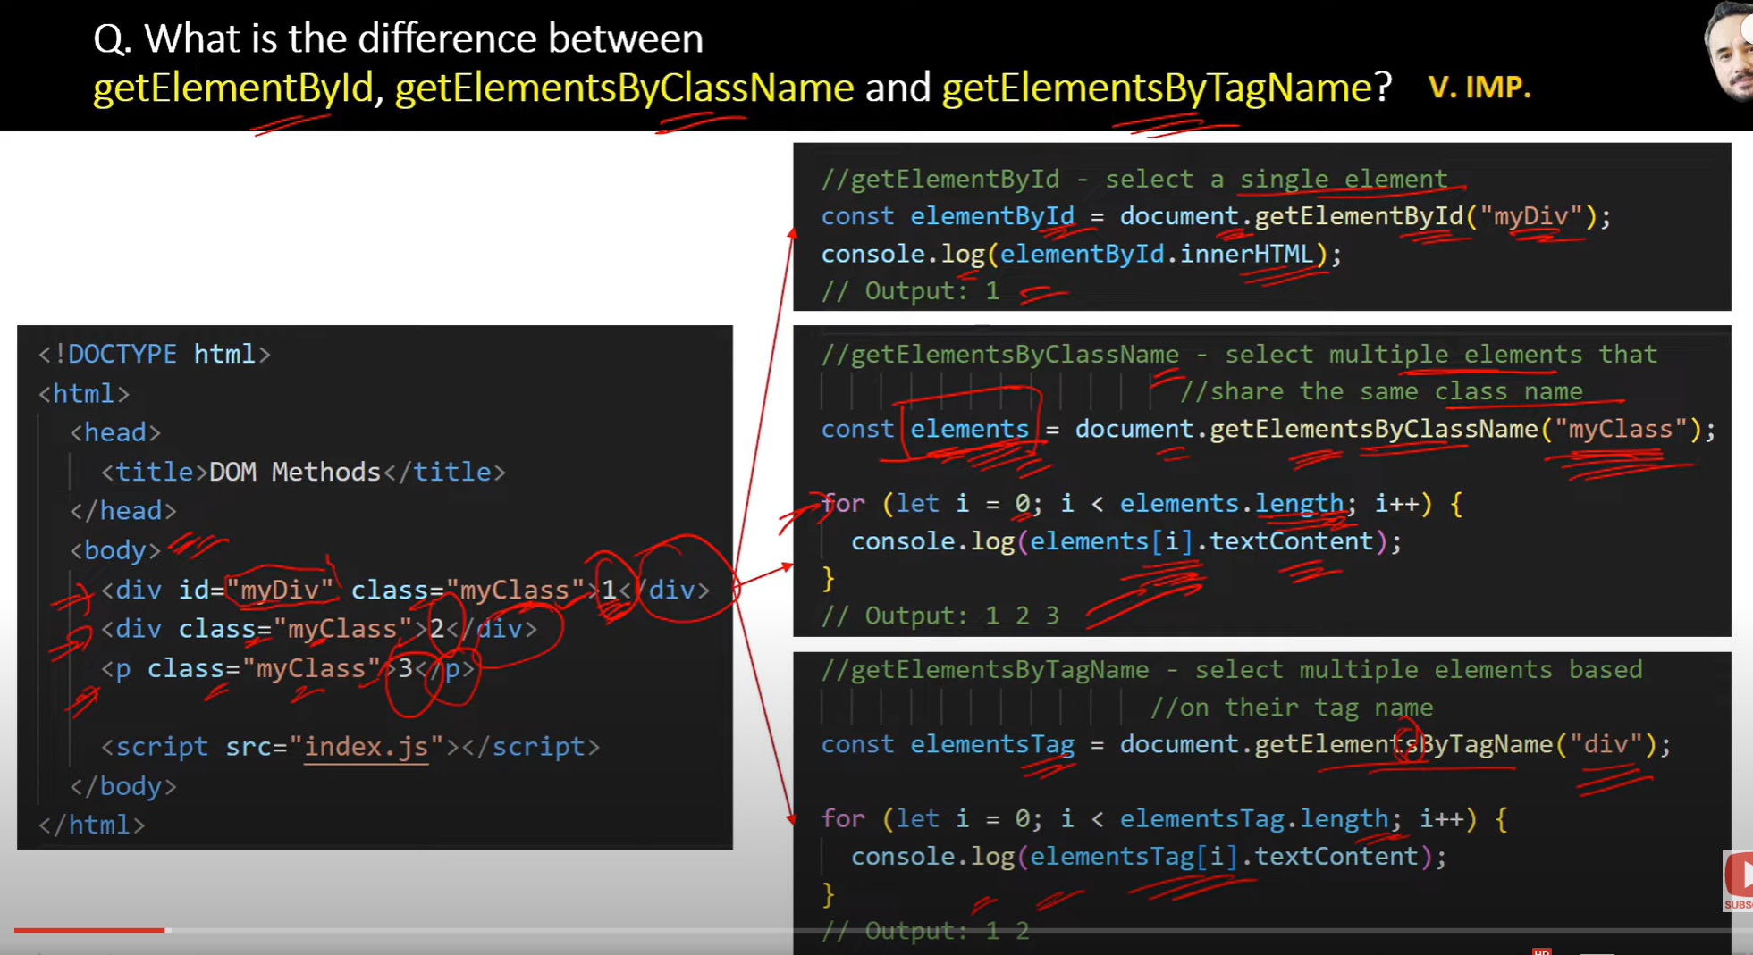

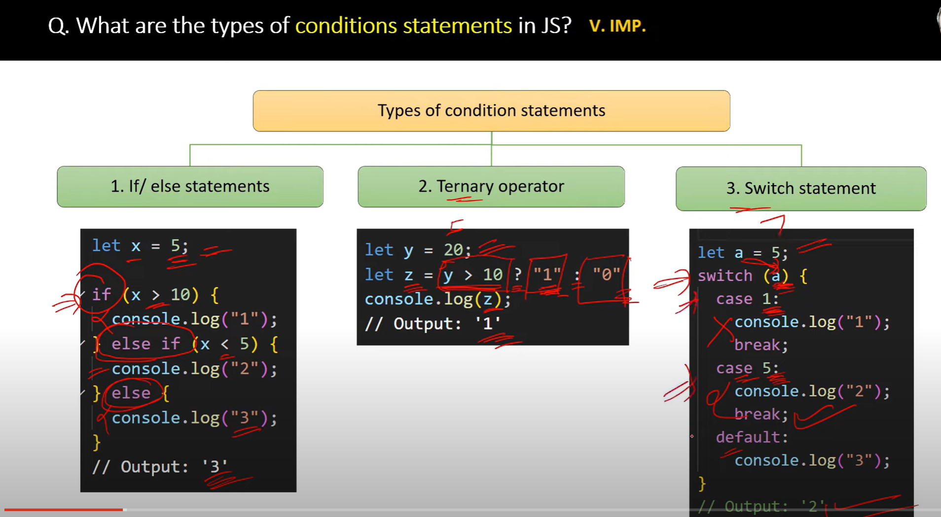

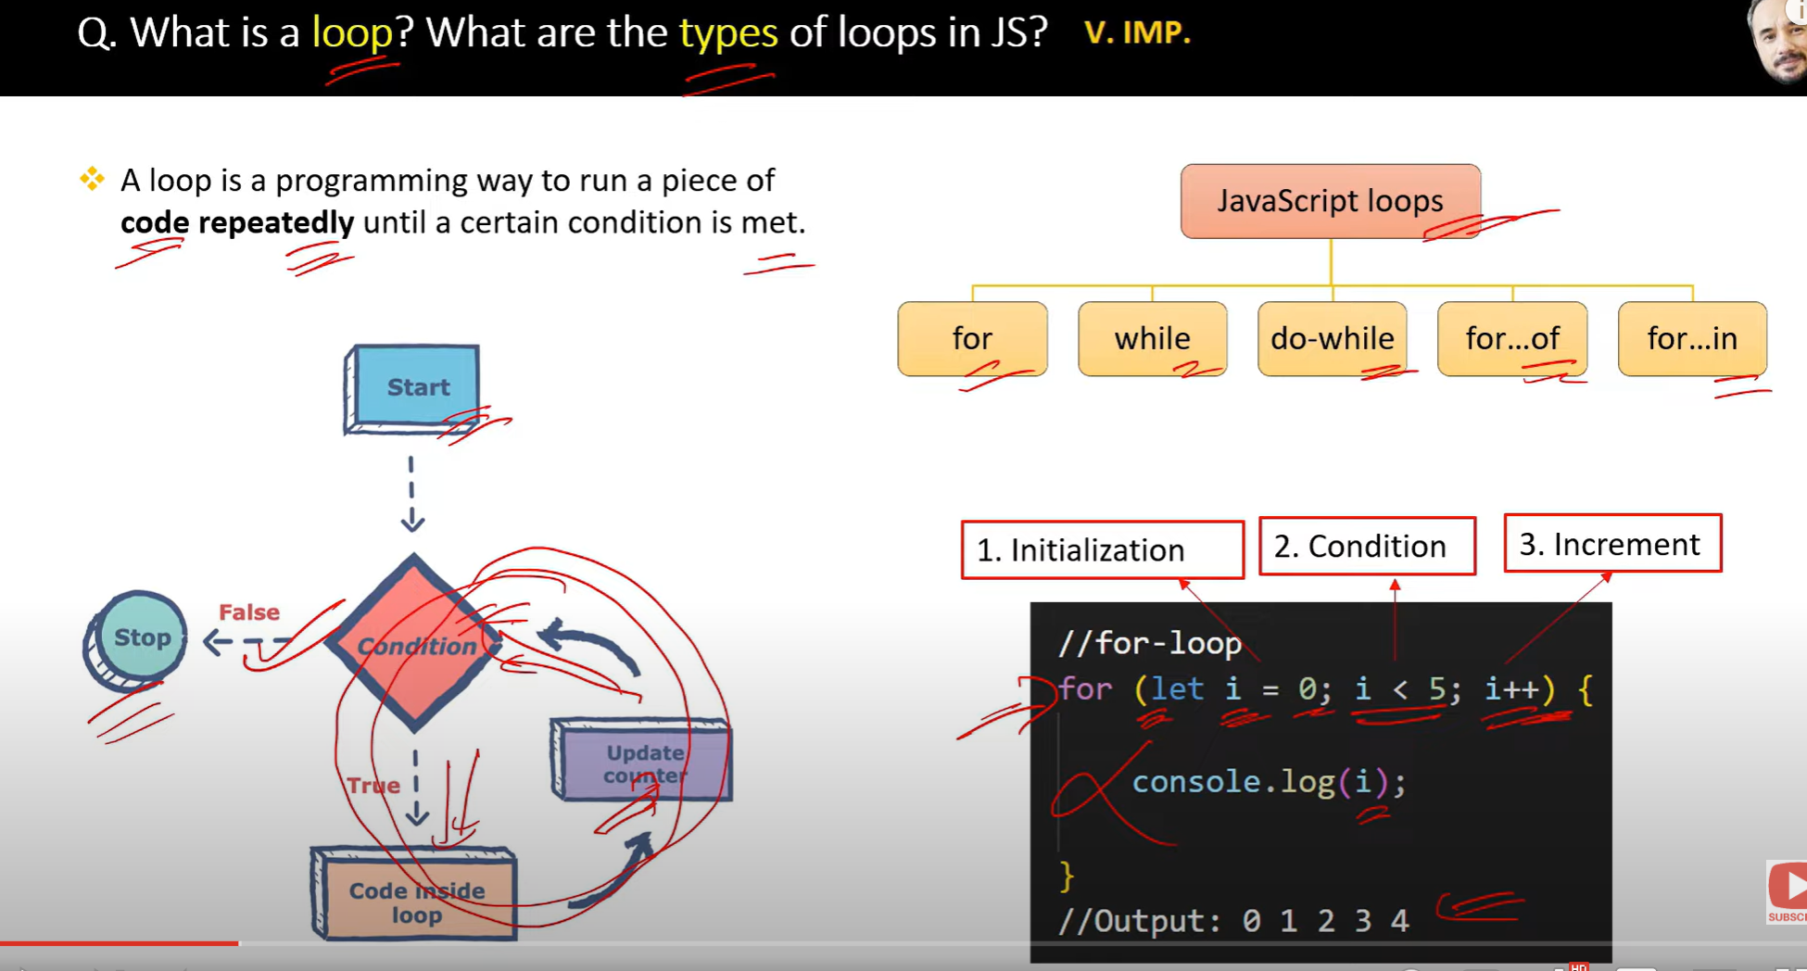

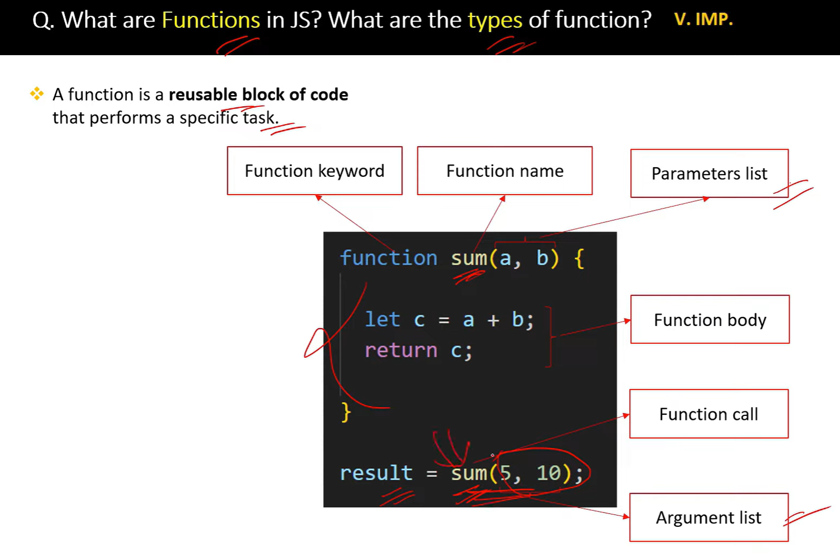

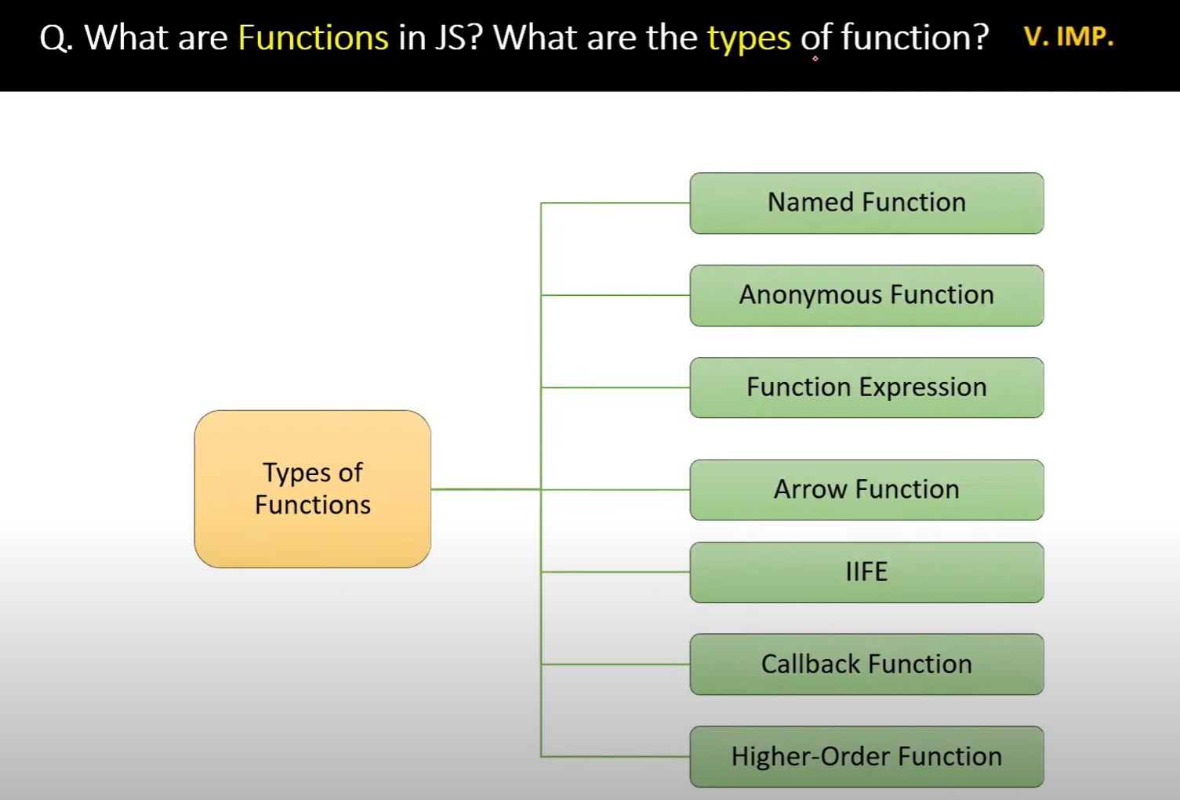

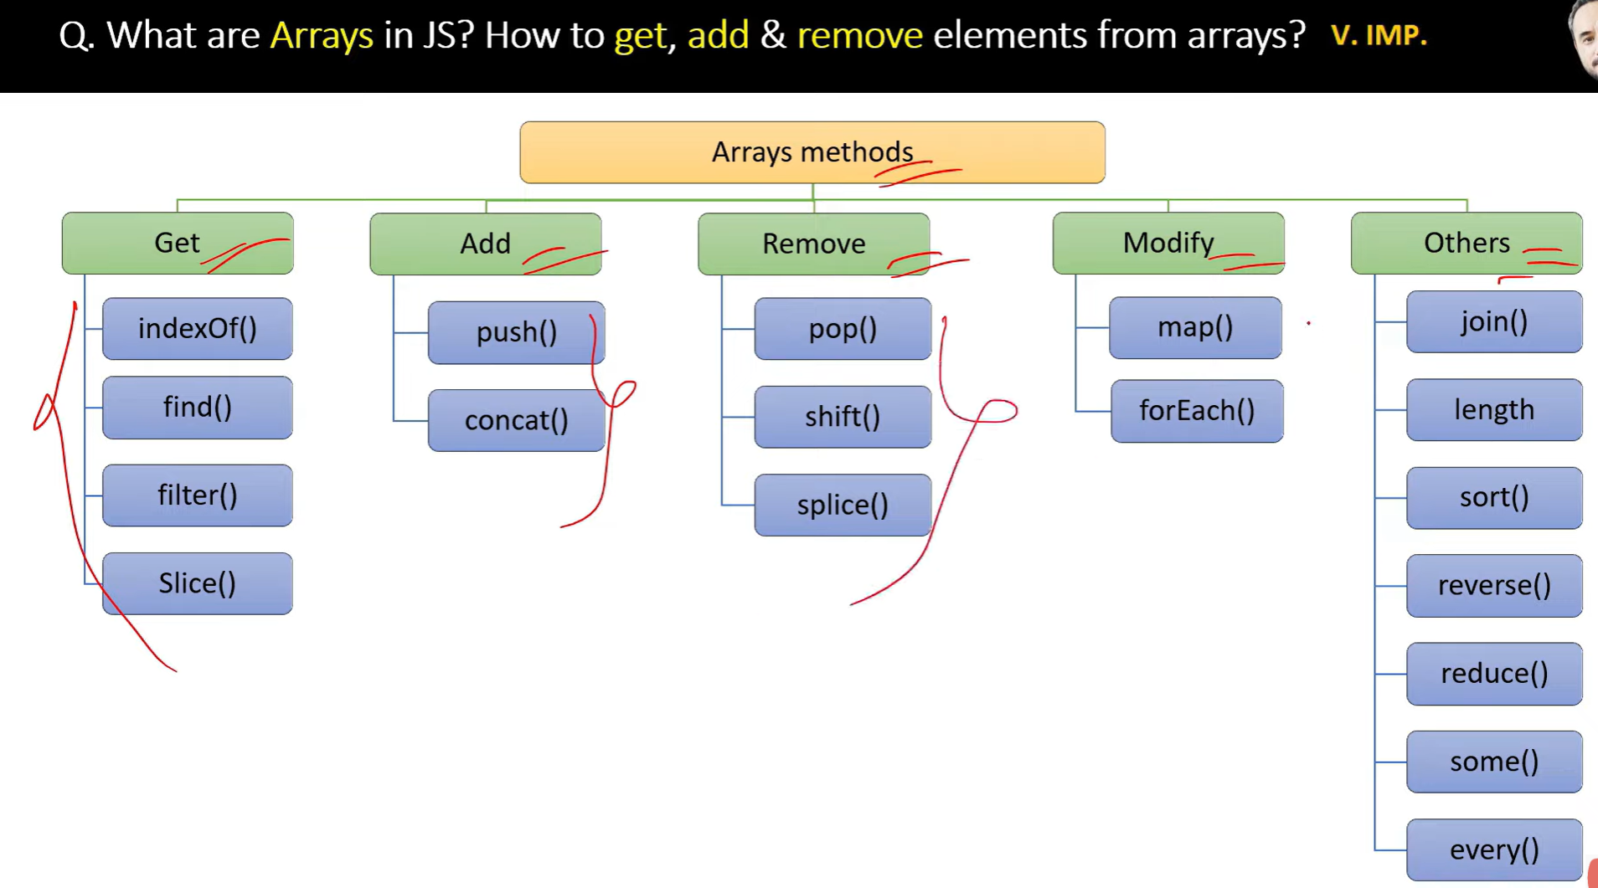

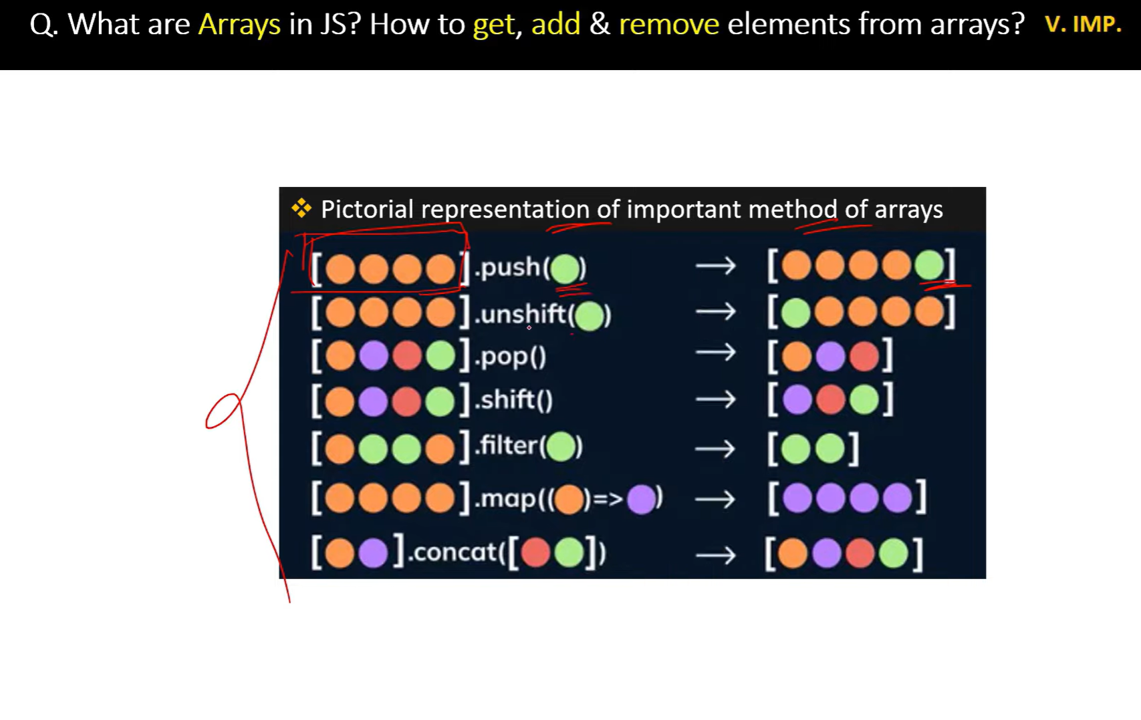

// map returns Array and also can chain with next method like filter, etc

// foreach doesnt return array but modifies the existing array.Also cannot chain

//=================Polifill of map====================

// creating own map function

Array.prototype.royMap= function(callback){

    let data=[];

    for(let i=0; i<this.length; i++){

        data.push(callback (this[i],i,this))

    }

    return data;

}

const mappedArray=[1,2,3].royMap((num,i,arr)=>{

    return num +3;

})

console.log(mappedArray)

// creating own filter function

Array.prototype.RoyFilter = function (callback){

let data =[];

for(let i=0;i<this.length; i++){

if(callback(this[i],i,this)){

data.push(this[i])

}}

return data

}

const mappedList=[1,2,3].RoyFilter((item,i)=>{

return item > 2

})

console.log(mappedList) // 3

// creating own reduce function

Array.prototype.royReduce = function (callback, initialValue) {

let accumulator = initialValue !== undefined ? initialValue : this[0];

let startIndex = initialValue !== undefined ? 0 : 1;

for (let i = startIndex; i < this.length; i++) {

accumulator = callback(accumulator, this[i], i, this);

}

return accumulator;

};

const reducedValue = [1, 2, 3, 4].royReduce((acc, num) => acc + num, 0);

console.log(reducedValue); // Output: 10

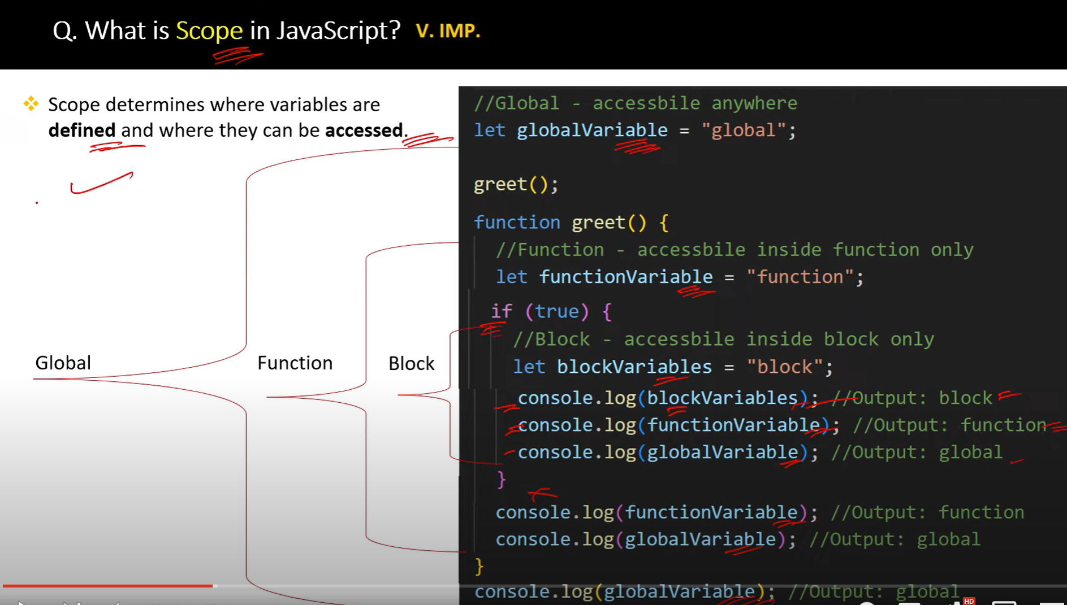

**closure** is a function that retains access to the variables from its **outer scope** even after the outer function has returned.

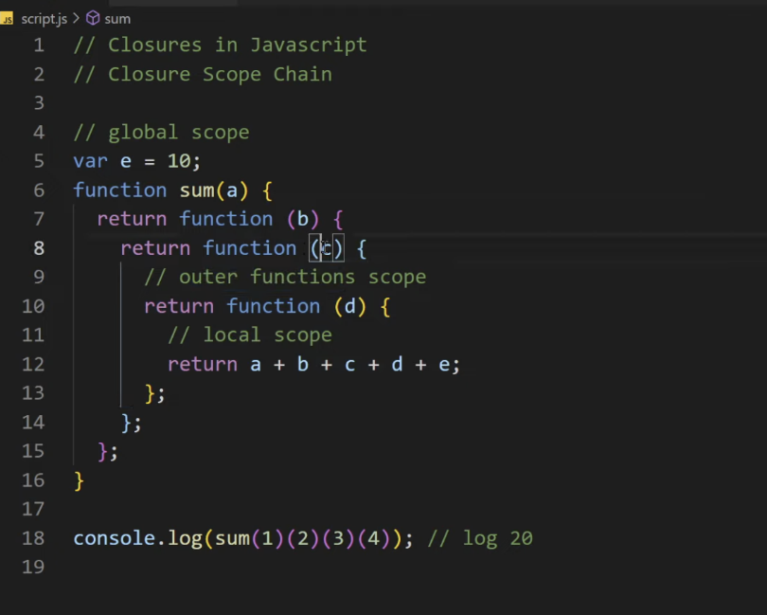

function outer() {

   let outerVar = "Hello";

   function inner() {

       console.log(outerVar);  // The inner function has access to `outerVar`

   }

   return inner;

}

const closureFunc = outer();  // outer() returns the inner function

closureFunc();  // Output: "Hello"

A closure is a function that "remembers" the environment in which it was created, even after the outer function has finished executing. This means the inner function has access to variables from its outer (enclosing) scope, even after the outer function has returned.

Key Characteristics of Closure:

Access to Outer Variables: A closure allows an inner function to access variables from its outer function even after the outer function has finished executing.

Private State: It can be used to create private variables and maintain state across function calls.

Function + Lexical Scope: The closure is created when a function is defined within another function, and it has access to variables in the outer function's scope.

Example of Closure:

javascript

Copy

Edit

function outer() {

let count = 0; // This is a private variable

return function inner() {

count++;

console.log(count);

};

}

const counter = outer();

counter(); // 1

counter(); // 2

counter(); // 3

In this example:

* The inner() function is defined within the outer() function.
* Even though outer() finishes executing when it returns inner(), the returned closureFunc still has access to the variable outerVar from the outer() function’s scope. This happens due to the closure.

**Currying** in JavaScript is a technique of transforming a function that takes multiple arguments into a sequence of functions that each take a single argument. In simple terms, currying allows you to break down a function with multiple parameters into a series of nested functions, each of which takes one argument and returns another function until all arguments are provided.

**Why Use Currying?**

Currying is useful for:

1. **Reusability**: It allows creating new functions by partially applying some of the arguments.
2. **Function Composition**: Curried functions can be easily composed with other functions to build more complex behavior.
3. **Delaying Execution**: Currying allows you to defer the execution of a function until all arguments are provided.

// Currying

1. function add(a) {
2. return function(b) {
3. return a + b;
4. };
5. }
6. const addTwo = add(2);  // Returns a new function that adds 2
7. console.log(addTwo(3));  // Output: 5
8. console.log(add(2)(3));  // Output: 5

// with arrow

const curriedMultiply = a => b => c => a * b * c;

const result = curriedMultiply(2)(3)(4); // 2 * 3 * 4 = 24

console.log(result);

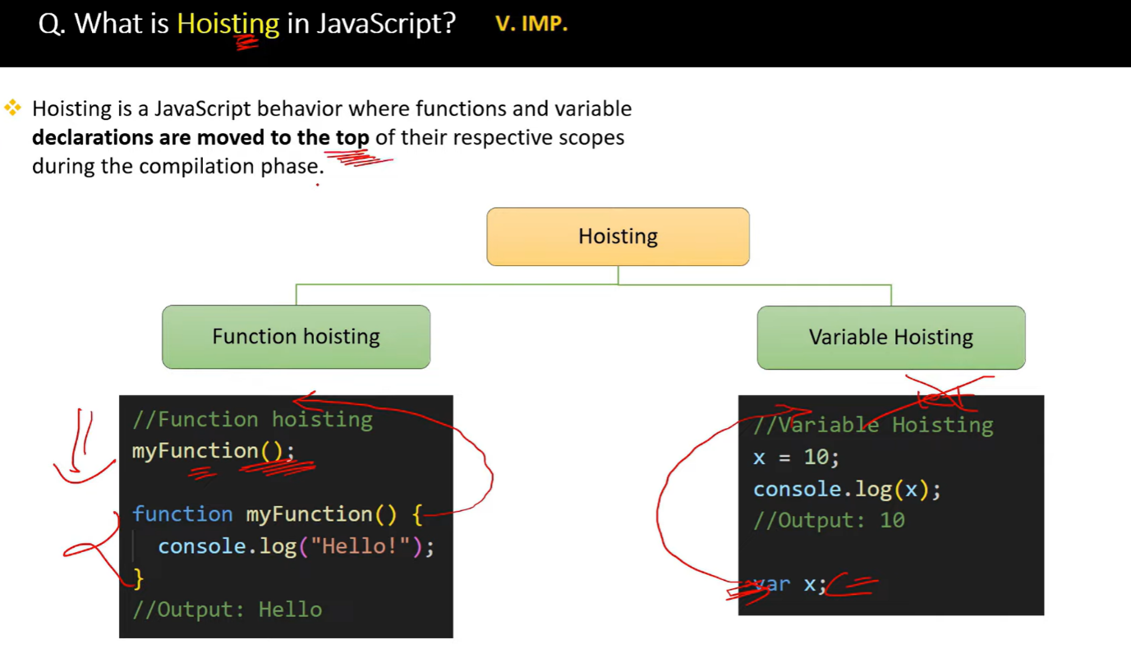

//===================Hoisting========================

function test() {

    console.log(a); // undeined

    console.log(b);  // not defined (temperial dead zone)

    console.log(c);  // not defined (temperial dead zone)

    var a = 6;

    let b = 7;

    const c = 9;

    }

    test();

//    Temporal Dead Zone refers to the period in the execution

    // of a JavaScript program where a variable exists but cannot be accessed.

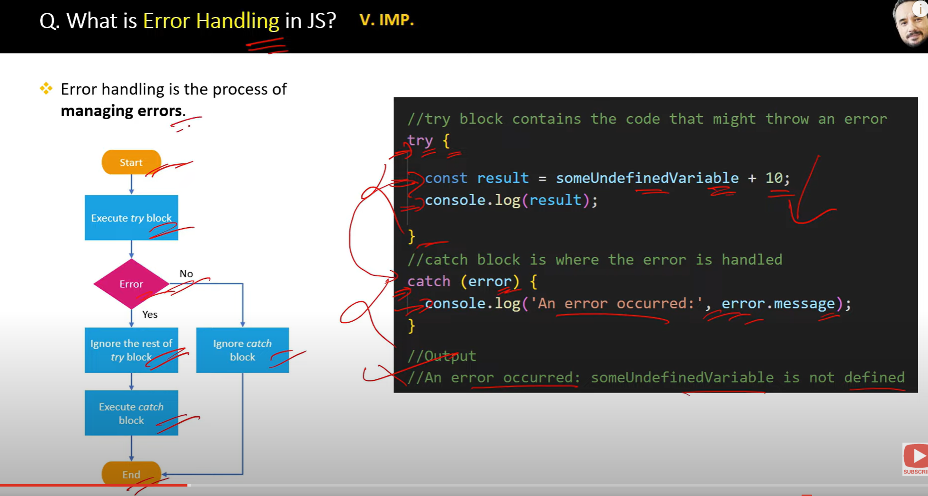

**CALL APPLY BIND**

Call method

**The call() method invokes a function immediately and allows you to specify the this value and pass individual arguments to the function.(obj, arg1, arg2, …)**

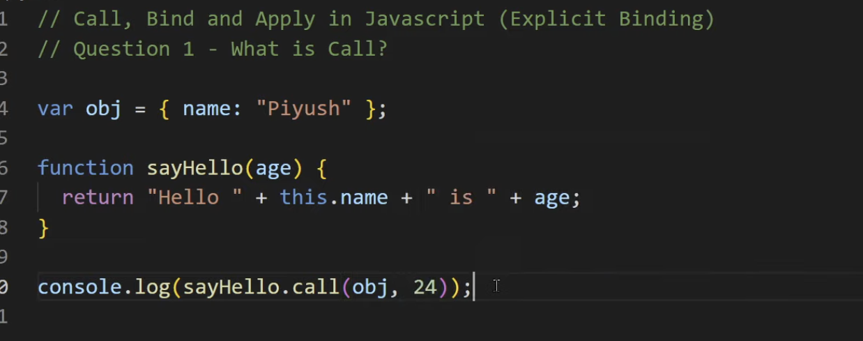

Apply

he apply() method is similar to call(), but instead of passing arguments individually, you pass them as an **array**. It also invokes the function immediately.

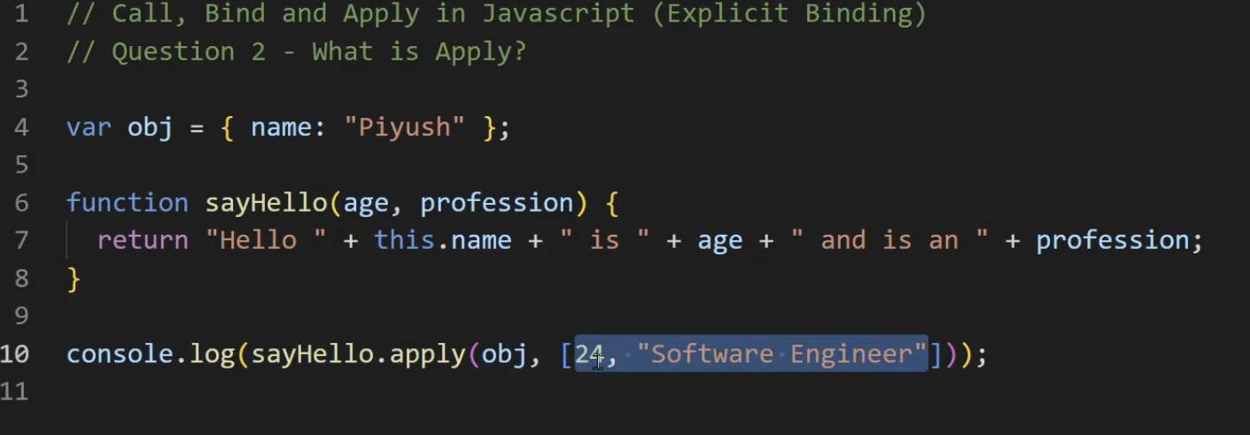

Bind (Resuable function) which in return another function

The bind() method does **not invoke the function immediately**. Instead, it returns a **new function** with a specific this value and (optionally) initial arguments, which can be invoked later.

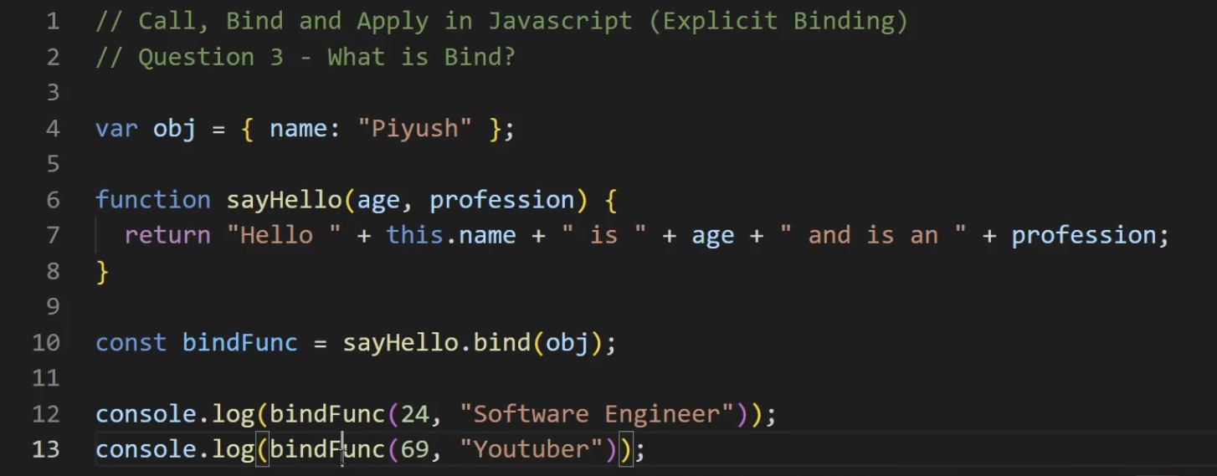

**Promise**

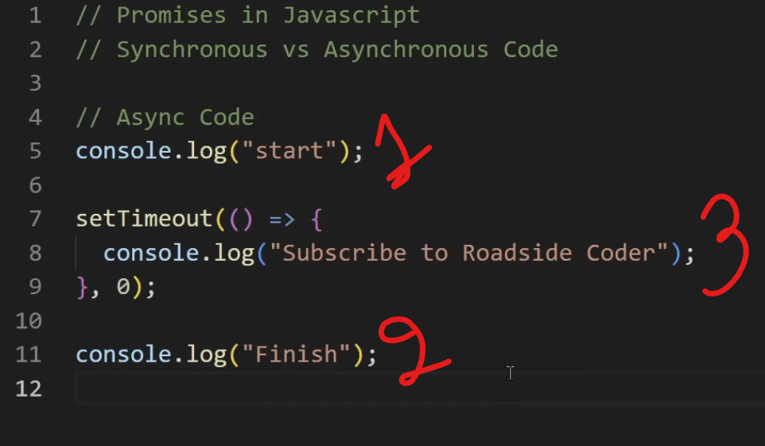

Callback hell nested callback

**Callback hell** refers to a situation in JavaScript (and other programming languages that use callbacks) where multiple nested callbacks lead to code that is difficult to read, maintain, and debug. It typically occurs in asynchronous programming when callbacks are used extensively, resulting in deeply nested structures that resemble a pyramid or "Christmas tree."

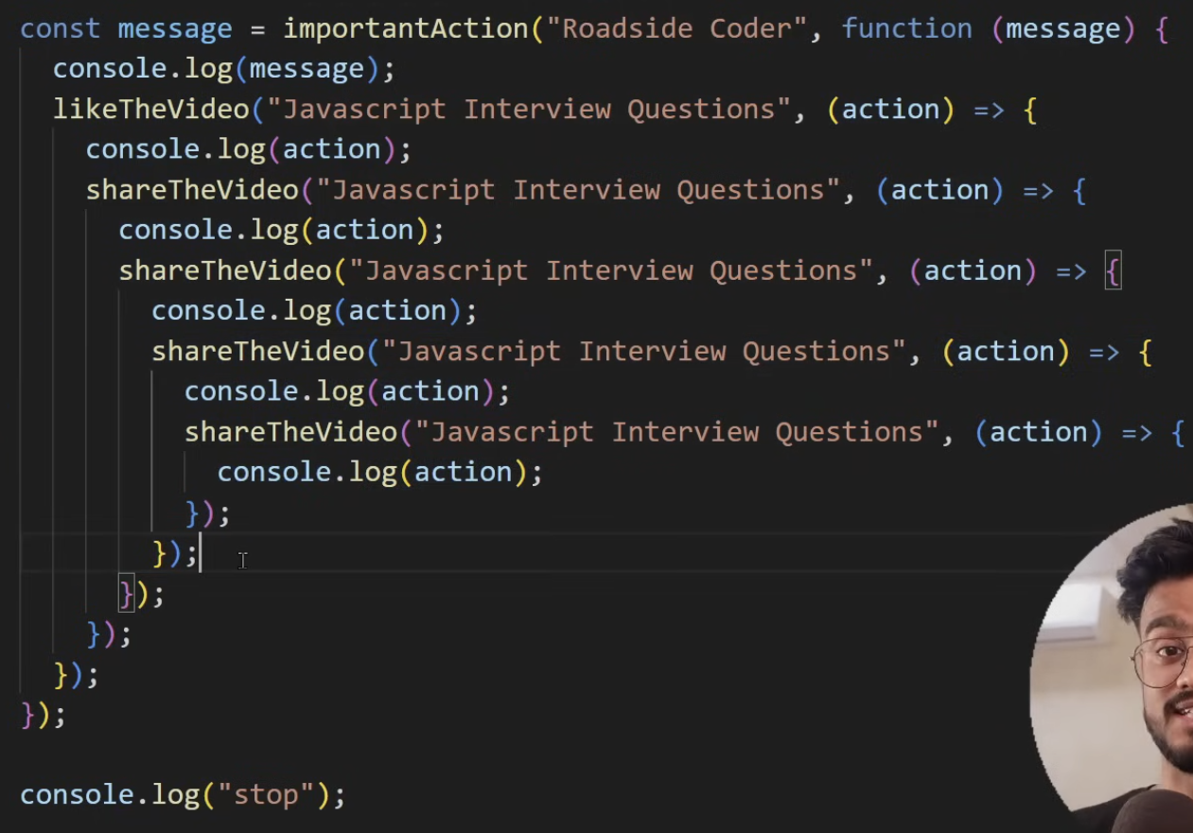

1. **Promises**: Use promises to handle asynchronous operations more cleanly, allowing for chaining and better error handling.
3. function performAsyncOperation() {
4. return new Promise((resolve, reject) => {
5. if(false){
6. return resolve({
7. hii:"hellow"
8. })
9. }else{
10. reject("Something went wrong.");
11. }
12. });
13. }
14. // Call the function and handle the Promise
15. performAsyncOperation()
16. .then(result => {
17. console.log(result); // Handle the resolved value
18. console.log("Operation completed");
19. })
20. .catch(error => {
21. console.error("Error:", error); // Handle any error
22. });**Async/Await**: Use async/await syntax for a more synchronous style of writing asynchronous code, which enhances readability.

javascript

async function performOperations() {

try {

const data = await getData();

const processedData = await processData(data);

const savedData = await saveData(processedData);

await sendConfirmation(savedData);

console.log("Operation completed");

} catch (error) {

console.error("Error:", error);

}

}

**Summary:**

* **Callback hell** makes code complex and difficult to manage due to excessive nesting of callbacks.
* Solutions include using modular functions, promises, or the async/await syntax to improve readability and maintainability.

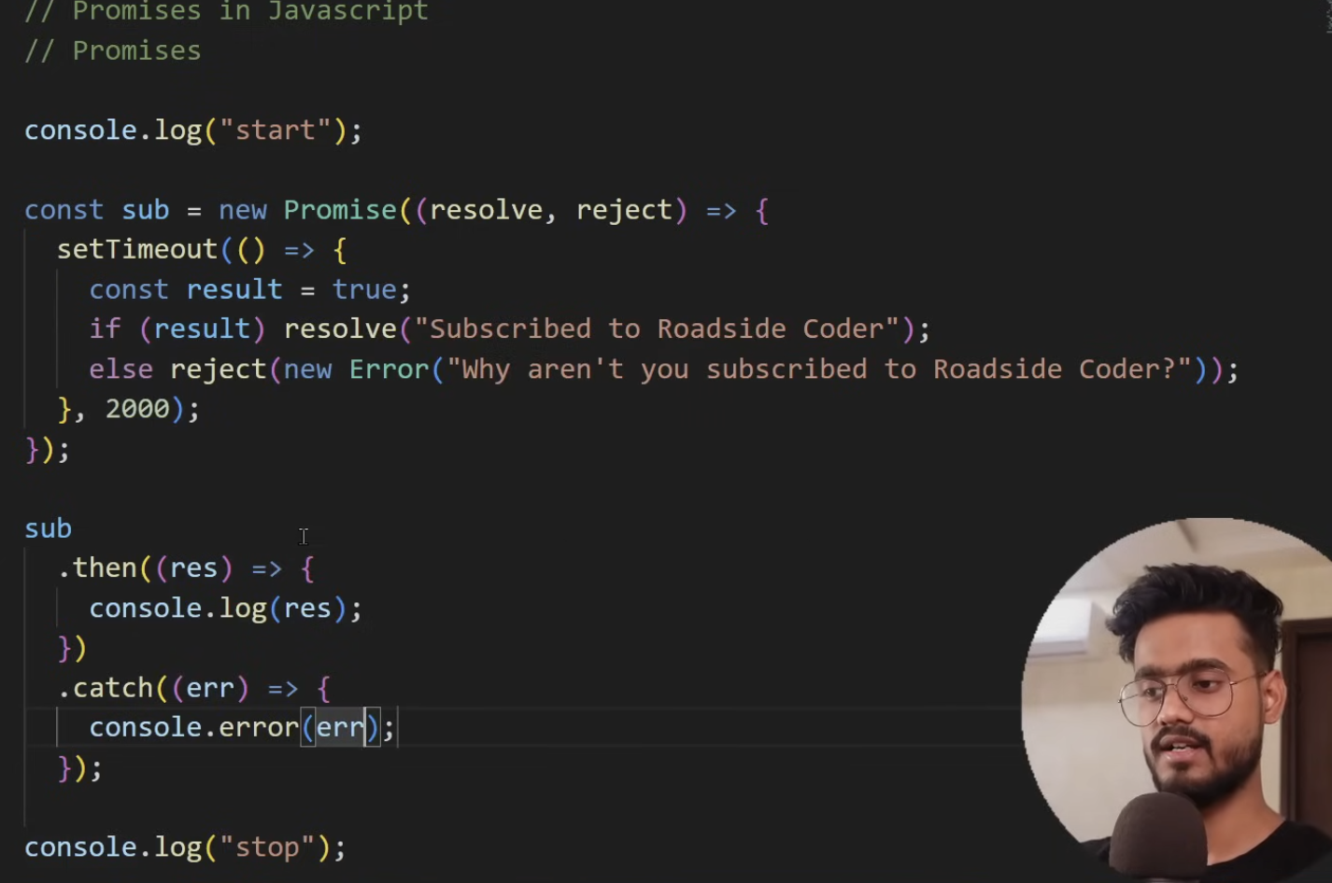

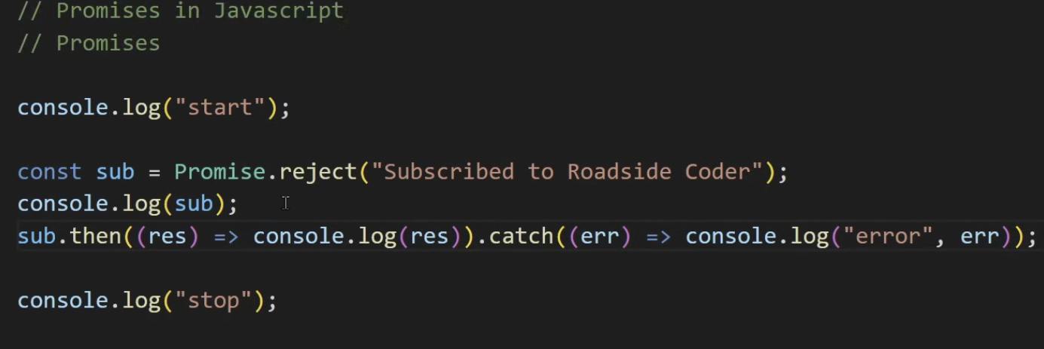

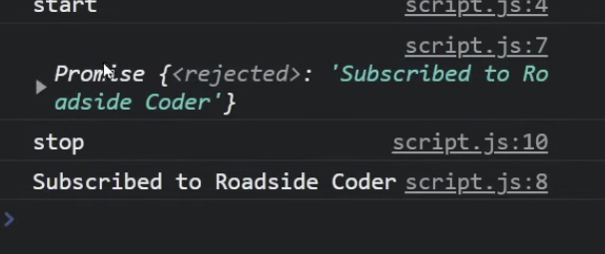

Promise.All => all should be reselved if one fails it wont execute

1. const promise1 = Promise.resolve(1);
2. const promise2 = Promise.resolve(2);
3. const promise3 = Promise.resolve(3);
4. Promise.all([promise1, promise2, promise3])
5. .then(results => { console.log('All promises resolved:', results); // [1, 2, 3] }) .catch(error => { console.error('One of the promises failed:', error); });

Promise.Race => Give any first promise resolved or failed

1. const promise1 = new Promise((resolve) => setTimeout(resolve, 2000, 'First'));
2. const promise2 = new Promise((resolve) => setTimeout(resolve, 1000, 'Second'));
3. Promise.race([promise1, promise2])
4. .then(result => { console.log('First settled:', result); // Second (because it resolves first) })
5. .catch(error => { console.error('Error:', error); });

Pomise.allSettled => return fulled with rejected inside resolved

1. const promise1 = Promise.resolve(1);
2. const promise2 = Promise.reject('Error occurred');
3. const promise3 = Promise.resolve(3);
4. Promise.allSettled([promise1, promise2, promise3])
5. .then(results => {
6. console.log('All promises settled:', results);
7. // Output:
8. // [
9. // { status: 'fulfilled', value: 1 },
10. // { status: 'rejected', reason: 'Error occurred' },
11. // { status: 'fulfilled', value: 3 }
12. // ]
13. });

Promise.any => first fulfilled promise and ignores all rejected ones

1. const promise1 = Promise.reject('First failed');
2. const promise2 = Promise.resolve('Second succeeded');
3. const promise3 = Promise.reject('Third failed');
4. Promise.any([promise1, promise2, promise3])
5. .then(result => {
6. console.log('First fulfilled promise:', result); // Second succeeded
7. })
8. .catch(error => {
9. console.error('All promises were rejected:', error);
10. });

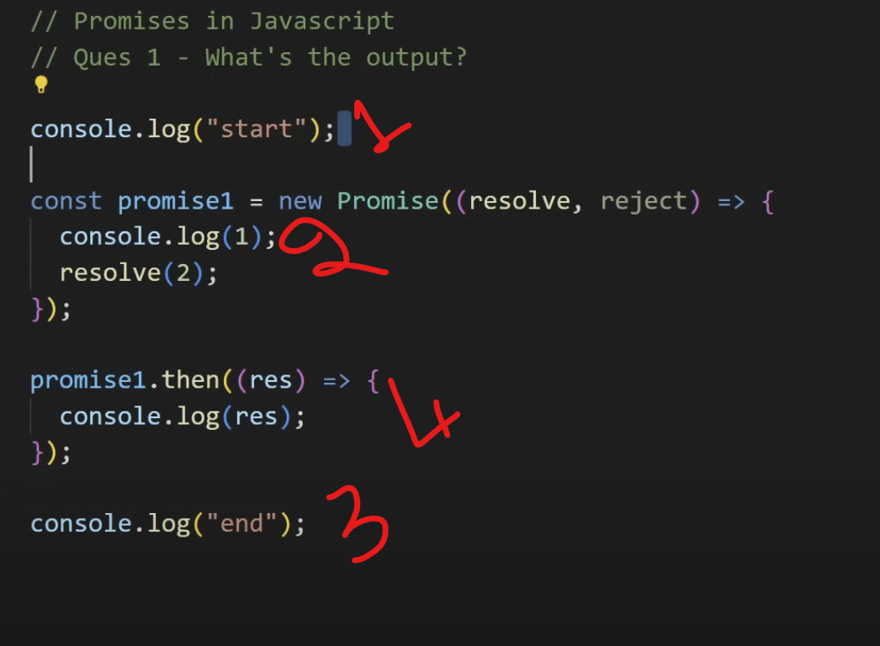

Debouncing =>It limit the execution of function call and waits for certain amount of time to running it again.

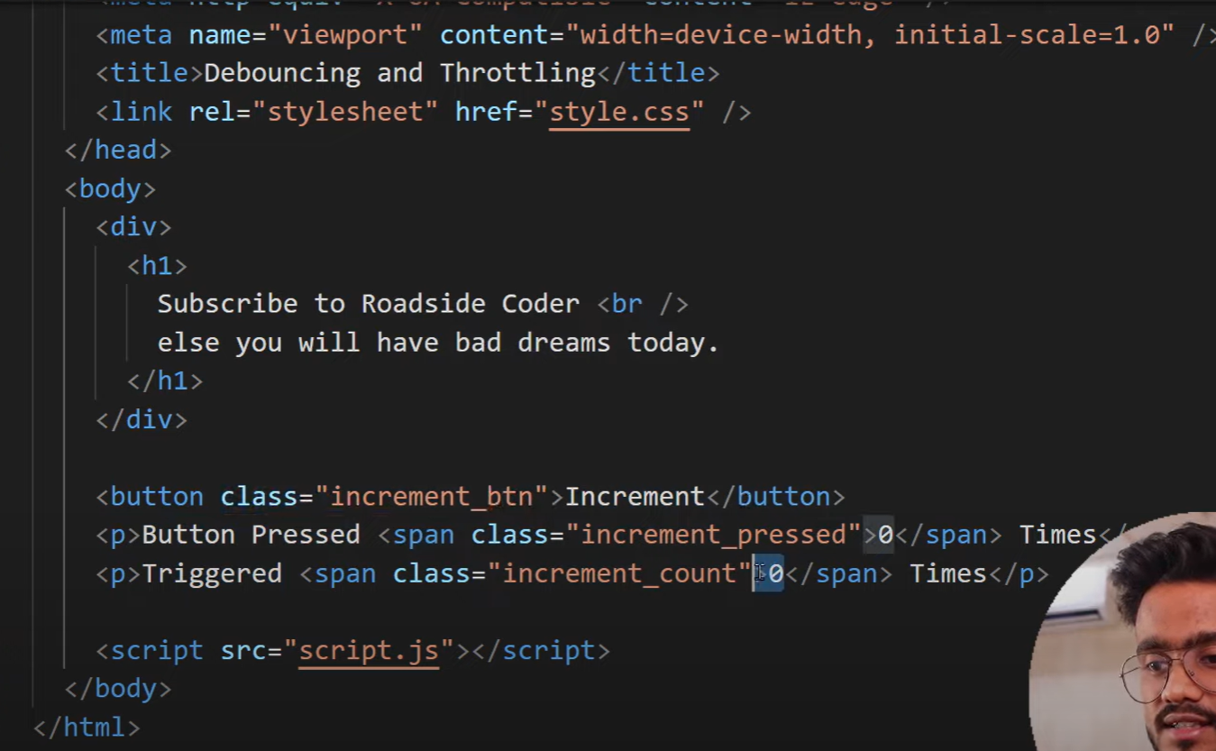

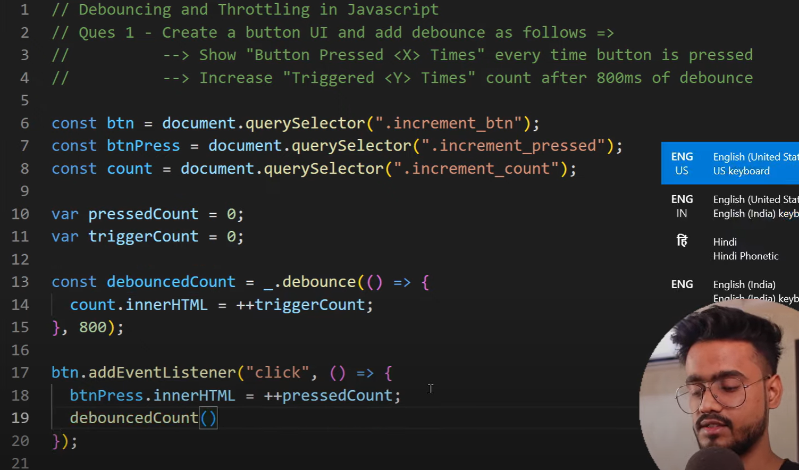

function debounce(func, delay) {

let timer;

return function (...args) {

clearTimeout(timer); // Clear the previous timer

timer = setTimeout(() => func.apply(this, args), delay); // Set a new timer

};

}

// Example usage:

const handleResize = debounce(() => {

console.log('Resize event handled');

}, 300);

window.addEventListener('resize', handleResize);

Throttling => It is the technique to limit the excecution of an event handler function even when this event triggers continuously.

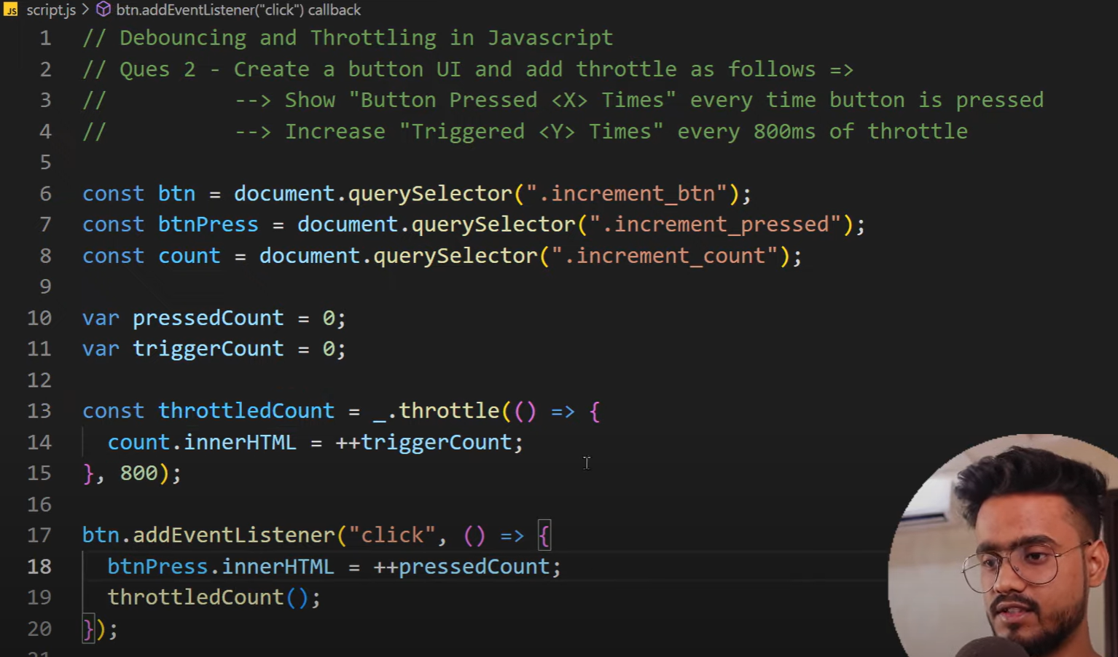

function throttle(func, interval) {

let lastCall = 0;

return function (...args) {

const now = Date.now();

if (now - lastCall >= interval) {

lastCall = now;

func.apply(this, args);

}

};

}

// Example usage:

const handleScroll = throttle(() => {

console.log('Scroll event handled');

}, 300);

window.addEventListener('scroll', handleScroll);

When you keep on clicking at add triggers in every 800 ms

**Differences Between Debounce and Throttle**

| **Feature** | **Debounce** | **Throttle** |
| --- | --- | --- |
| **Execution Frequency** | Executes once, after a delay, and resets on new events. | Executes at regular intervals. |
| **Purpose** | Wait until the event stops firing. | Limit the number of executions. |
| **Use Case** | Search bar, resize events. | Scroll events, rate-limiting APIs. |

**Event Bubling and event capturing**  
  
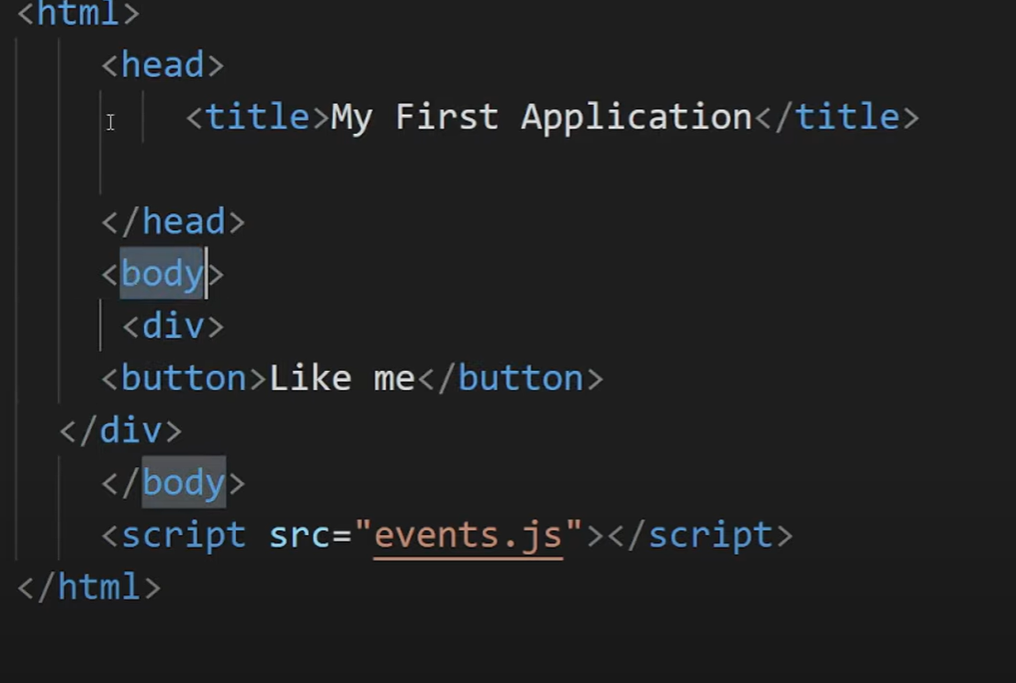

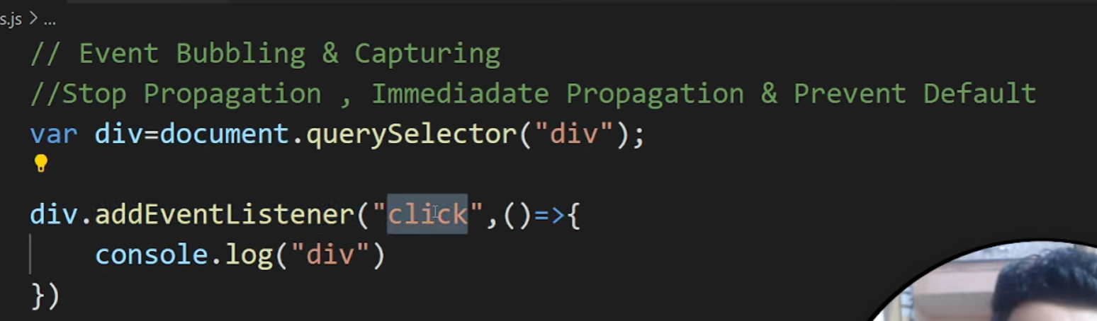

**Event bubbling** is a mechanism in JavaScript where an event starts from the **target element** and then propagates (or "bubbles up") to its **parent elements**. This continues until the event reaches the **document**.

**In above images div is printed when you click on button**

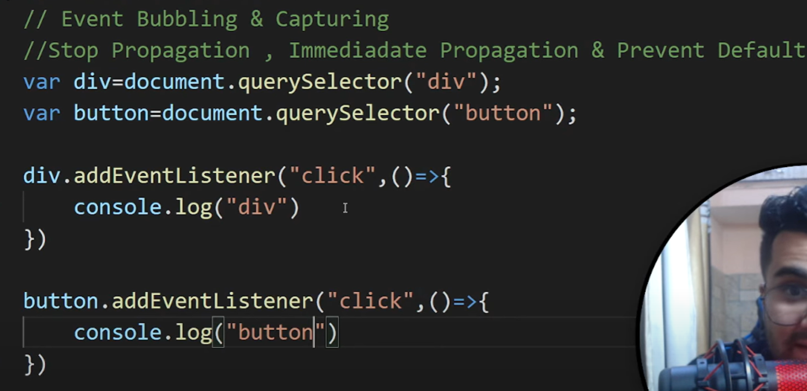

**In above image Button I printed and then div in console.**

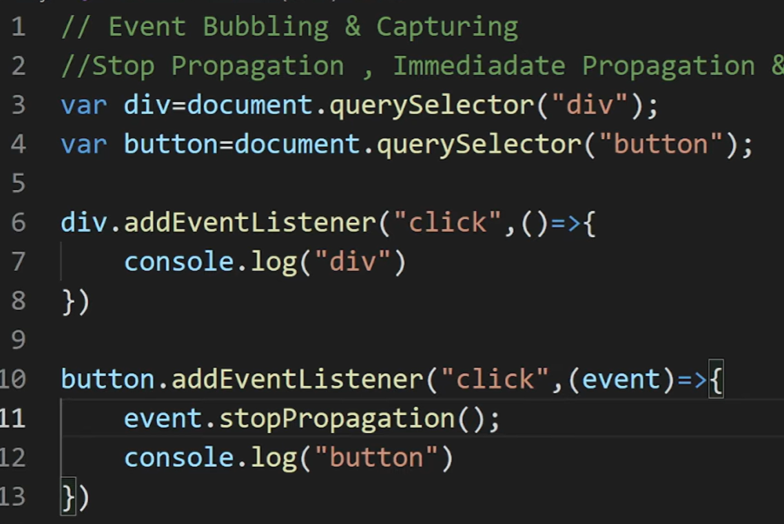

**I can stop event propagation……**

**e.stopImmediatePropogation()**

**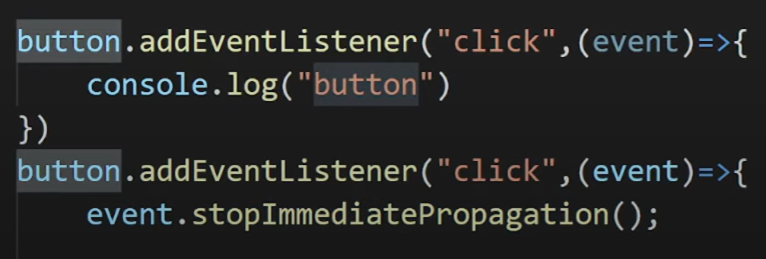  
if you have multiple event lister for button it will liston on button one and button2 and stops**

